
Database Management Systems I
Assignment 02

Title : Video Rental System
Batch Number : DIT....
Due Date : | Date of Submission :
Lab Group (Date/Time): | Lab Number :
Instructors :
Declaration:
We hold a copy of this assignment that we can produce if the original is lost or damaged.
We hereby certify that no part of this assignment has been copied from any other group’s work or from any other source. No part of this assignment has been written / produced for our group by another person except where such collaboration has been authorized by the subject lecturer/tutor concerned.
Group Members: DBMS Project Group Number:

Note: An examiner or lecturer/tutor has the right not to mark this assignment if the above declaration has not been signed)

DIT/11/C2/0328 Lakmini Kirinda ……………………………
DIT/11/C2/0343 Sumangi Piumika ……………………………
DIT/11/C2/0345 Eranda Jayarathna ……………………………
DIT/11/C2/0353 Yasitha Bangamuwage ……………………………
DIT/11/C2/0357 Isuru Chathuranga ……………………………


Introduction

www.sliitrevolution.yolasite.com
Video Rental System
They have plenty of VCD and DVD videos for rent. Currently they handle about 500 customers per month. Right now they keep their data manually. The Cinemax video rental company wants to design a relational database system to store information about their customers and their videotapes.
According to their current data system they have to face following problems that, difficult to search videos and customer details, their stocks are rapidly increasing. Therefore it’s more difficult to maintain their stocks. Sometimes customers do not return their items before deadline, it’s more problematic to find them. Because of above difficulties, their time also wasting.
Our database will solve this problem by storing all these data using SQL giving easy access to the data needed. Employees will have full access to stock details as well as sales and purchases. This will enable them to clearly identify shortages in stocks and also the customer preferences that will enable them to improve their sales.

Final Schema For the Database

Supplier
sid | name | address

Customer
cid | NICNo | lname | fname | address

Type
tid | name

Division
did | name | location | phoneNo

Movie
ItemNo | copyNo | title | language | availability |  | duration | rent | Released  date | Rack  No | supplier
type | sup_payment |  | sup_date

Employee
eid | lname | fname | address | jointDate | Division | NICNo

C_Borrow_and_Return
itemNo | copyNo | customer | payment | borrowedDate | returnDate | fine

E_Borrow_and_Return
itemNo | copyNo | Employee | discount | payment | borrowedDate | returnDate

Customer_Phone_No
Customer | phoneNo

Customer_Email
Customer | email

Supplier_Phone_No
Supplier | phoneNo

Supplier_Email
Supplier | email

Employee_Phone_No
Employee | phoneNo

Employee_Email
Employee
Create Table Commands (with necessary instructions)
CREATE TABLE SupplierC2207
(
sid char(5) ,
name varchar(30) check (name is not null),
address varchar(60),

constraint Supplier_PK_sid primary key(sid)

);

CREATE TABLE CustomerC2207
(
cid char(5) ,
NICNo char(10) check (NICNo like '[0-9][0-9][0-9][0-9][0-9][0-9][0-9][0-9][0-9][VXvx]'),
lname varchar(30),
fname varchar(30),
address varchar(60),

constraint Customer_PK_cid primary key(cid)

);

CREATE TABLE TypeC2207
(
tid char(5) ,
name varchar(30) check (name is not null),

constraint Type_PK_tid primary key(tid)

);

CREATE TABLE DivisionC2207
(
did char(5) ,
name varchar(20) check (name is not null),
location varchar(30),
phoneNo char(10) check (phoneNo like '[0-9][0-9][0-9][0-9][0-9][0-9][0-9][0-9][0-9][0-9]'),

constraint Division_PK_did primary key(did)

);

CREATE TABLE Movie_ItemC2207
(
itemNo char(5) ,
title varchar(50) check (title is not null),
language varchar(10),
duration char(20),
rent float check (rent is not null),
relesed_date date,
rackNo char(5) check (rackNo is not null),
type char(5),

constraint Movie_PK_item primary key(itemNo),

constraint Movie_FK_tid foreign key(type) references TypeC2207(tid)

);

CREATE TABLE Movie_CopyC2207
(
itemNo char(5) ,
copyNo char(5) ,
availability char(12) check (availability in ('Available','Unavailable')),
supplier char(5),
sup_payment float,
sup_date date,

constraint Moviec_PK_item primary key(itemNo,copyNo),

constraint Movie_FK_sid foreign key(supplier) references SupplierC2207(sid),
constraint Movie_FK_item foreign key(itemNo) references Movie_ItemC2207(itemNo),

);

CREATE TABLE EmployeeC2207
(
eid char(5) ,
fname varchar(30) check (fname is not null),
lname varchar(30) check (lname is not null),
address varchar(60),
jointDate date,
Division char(5),
NICNo varchar(10) check (NICNo like '[0-9][0-9][0-9][0-9][0-9][0-9][0-9][0-9][0-9][VXvx]'),

constraint Employee_PK_eid primary key(eid),

constraint Employee_FK_did foreign key(Division) references DivisionC2207(did)

);

CREATE TABLE C_Borrow_and_ReturnC2207
(

itemNo char(5) ,
copyNo char(5) ,
customer char(5) ,
payment float check (payment is not null),
borrowedDate date check (borrowedDate is not null),
returnDate date,
fine float,

constraint CBorrow_and_Return_PK primary key(itemNo,copyNo,customer),

constraint CBorrow_and_Return_FK_item foreign key(itemNo,copyNo) references Movie_CopyC2207(itemNo,copyNo),
constraint CBorrow_and_Return_FK_cid foreign key(customer) references customerC2207(cid)

);

CREATE TABLE E_Borrow_and_ReturnC2207
(

itemNo char(5) ,
copyNo char(5) ,
Employee char(5) ,
discount integer,
payment float check (payment is not null),
borrowedDate date check (borrowedDate is not null),
returnDate date,

constraint EBorrow_and_Return_PK primary key(itemNo,copyNo,Employee),

constraint EBorrow_and_Return_FK_item foreign key(itemNo,copyNo) references Movie_CopyC2207(itemNo,copyNo),
constraint EBorrow_and_Return_FK_cid foreign key(Employee) references EmployeeC2207(eid)

);

CREATE TABLE Customer_Phone_NoC2207
(
Customer char(5),
phoneNo varchar(10) check (phoneNo like '[0-9][0-9][0-9][0-9][0-9][0-9][0-9][0-9][0-9][0-9]'),

constraint CustomerPhoneNo_PK primary key(Customer,phoneNo),

constraint CustomerPhoneNo_FK_cid foreign key(Customer) references CustomerC2207(cid)

);

CREATE TABLE Customer_EmailC2207
(
Customer char(5),
email varchar(30) check (email like ('%[@]%[.]%')),

constraint CustomerEmail_PK primary key(Customer,email),

constraint CustomerEmail_FK_cid foreign key(Customer) references CustomerC2207(cid)

);

CREATE TABLE Supplier_Phone_NoC2207
(
Supplier char(5),
phoneNo varchar(10) check (phoneNo like '[0-9][0-9][0-9][0-9][0-9][0-9][0-9][0-9][0-9][0-9]'),

constraint Supplier_ph_FK foreign key(supplier) references SupplierC2207(sid),

constraint Supplier_ph_PK primary key(supplier,phoneNo)
);

CREATE TABLE Supplier_EmailC2207
(
Supplier char(5),
email varchar(30) check (email like ('%[@]%[.]%')),

constraint Supplier_email_FK foreign key(supplier) references SupplierC2207(sid),

constraint Supplier_emai_PK primary key(supplier,email)
);

CREATE TABLE Employee_Phone_NoC2207
(
Employee char(5),
phoneNo varchar(10) check (phoneNo like '[0-9][0-9][0-9][0-9][0-9][0-9][0-9][0-9][0-9][0-9]'),

constraint Emp_phone_FK foreign key(Employee) references EmployeeC2207(eid),

constraint Emp_emai_PK primary key(Employee,phoneNo)
);

CREATE TABLE Employee_EmailC2207
(
Employee char(5),
email varchar (30) check (email like ('%[@]%[.]%')),

constraint Emp_email_FK foreign key(Employee) references EmployeeC2207(eid),

constraint Emp_email_PK primary key(Employee,email)
);

Data Insert

Supplier Table
insert into SupplierC2207
values('S01','B.G.Perera','no 23,1st lane,Piliyandala');

insert into SupplierC2207
values('S02','Ravin Gunasekara','No 100,samagi mv,Kelaniya');

insert into SupplierC2207
values('S03','S.E.Jayarathane','Hilton road,Colombo 7');

insert into SupplierC2207
values('S04','Akila Peramuna','No 21,2nd Lane,Moratuwa');

Customer Table
insert into CustomerC2207
values('C01','234756897v','Bangamuwage','Thilantha','No 100,Premarathana mv,Madapatha');

insert into CustomerC2207
values('C02','346907864v','Anurudhika','Dilhari','N0 34,Isurupura,Kesbewa');

insert into CustomerC2207
values('C03','098564234v','Wanigasekara','Sajeevi','Subodhi road,Miriswatha');

insert into CustomerC2207
values('C04','198304273v','Perera','Madhuranga','No 78,Temple road,Kaluthara');

Type Table
insert into TypeC2207
values('T01','Horror');

insert into TypeC2207
values('T02','Adventure');

insert into TypeC2207
values('T03','Comedy');

insert into TypeC2207
values('T04','Action');

Division Table
insert into DivisionC2207
values('01','Management','Building01','0112789012');

insert into DivisionC2207
values('02','Customer Service','Building02','0112678901');

insert into DivisionC2207
values('03','Cleaning','Building02','0112567890');

insert into DivisionC2207
values('04','Security','Building02','0112456789');

Movie Table
insert into Movie_ItemC2207
values('M004','Drive','English','100 min',50,'09-16-2011','R01','T04');

insert into Movie_ItemC2207
values('M005','Thor','English','115 min',60,'04-06-2011 ','R02','T04');

insert into Movie_ItemC2207
values('M006','Friends with Benefits','English','105 min',50,'07-22-2011','R05','T05');

insert into Movie_ItemC2207
values('M007','A Little Bit of Heaven','English','106 min',50,' 06-10-2011 ','R06','T05');

C_Borrow_and_Return Table
insert into C_Borrow_and_ReturnC2207
values('M006','01','C04',50,'09/21/2011',null,00);

insert into C_Borrow_and_ReturnC2207
values('M007','01','C02',50,'09/16/2011',null,00);

insert into C_Borrow_and_ReturnC2207
values('M013','01','C01',60,'04/20/2011','04/22/2011',00);

insert into C_Borrow_and_ReturnC2207
values('M010','01','C10',60,'06/03/2011','06/10/2011',00);

E_Borrow_and_Return Table
insert into E_Borrow_and_ReturnC2207
values('M007','02','E003',10,40,'08/19/2011','08/26/2011');

insert into E_Borrow_and_ReturnC2207
values('M011','03','E001',15,55,'08/22/2011','08/25/2011');

insert into E_Borrow_and_ReturnC2207
values('M009','02','E002',15,55,'09/24/2011',null);

insert into E_Borrow_and_ReturnC2207
values('M014','01','E005',15,55,'07/10/2011','07/15/2011');

Customer_Phone_No Table
insert into Customer_Phone_NoC2207
values('C01','0712384032');

insert into Customer_Phone_NoC2207
values('C01','0713482741');

insert into Customer_Phone_NoC2207
values('C02','0772312832');

insert into Customer_Phone_NoC2207
values('C03','0712342389');

Customer_Email Table
insert into Customer_EmailC2207
values('C01','thilantha@yahoo.com');

insert into Customer_EmailC2207
values('C01','yasitha2k9@gmail.com');

insert into Customer_EmailC2207
values('C02','dilhari@gmail.com');

insert into Customer_EmailC2207
values('C03','sajivi@gmail.com');

Supplier_Phone Table
insert into Supplier_Phone_NoC2207
values('S01','0712378945');

insert into Supplier_Phone_NoC2207
values('S02','0724535675');

insert into Supplier_Phone_NoC2207
values('S03','0783412342');

insert into Supplier_Phone_NoC2207
values('S04','0715687890');

Supplier_Email Table
insert into Supplier_EmailC2207
values('S01','pererarox@gmail.com');

insert into supplier_EmailC2207
values('S02','ravin_movie@yahoo.com');

insert into supplier_EmailC2207
values('S03','jayarathna@gmail.com');

insert into supplier_EmailC2207
values('S04','akila2k8@yahoo.com');

Employee_Phone Table
insert into Employee_Phone_noC2207
values('E001','0710485346');

insert into Employee_Phone_noC2207
values('E001','0773478904');

insert into Employee_Phone_noC2207
values('E002','0784567382');

insert into Employee_Phone_noC2207
values('E002','0785690384');

Employee_Email Table
insert into Employee_EmailC2207
values('E001','Samaravira@yahoo.com');

insert into Employee_EmailC2207
values('E001','isuru_samaravira@gmail.com');

insert into Employee_EmailC2207
values('E002','Wigesundhara@yahoo.com');

insert into Employee_EmailC2207
values('E002','sampath2k9@gmail.com');

Tables With Sample Values

SELECT *
FROM SupplierC2207

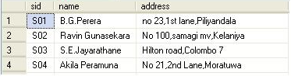

SELECT *
FROM CustomerC2207

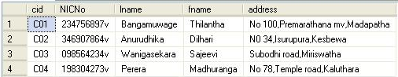

SELECT *
FROM TypeC2207

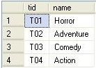

SELECT *
FROM DivisionC2207

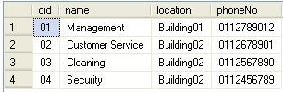

SELECT *
FROM Movie_ItemC2207

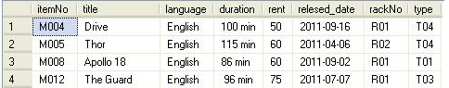

SELECT *
FROM Movie_CopyC2207

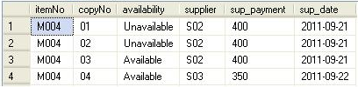

SELECT *
FROM EmployeeC2207

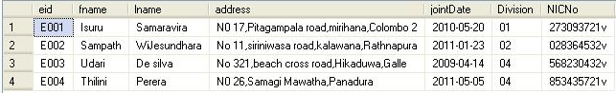

SELECT *
FROM C_Borrow_and_ReturnC2207

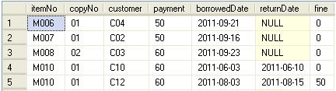

SELECT *
FROM E_Borrow_and_ReturnC2207

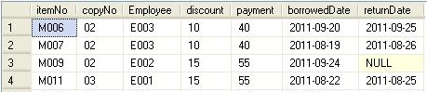

SELECT *
FROM Customer_Phone_NoC2207

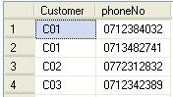

SELECT *
FROM Customer_EmailC2207

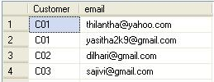

SELECT *
FROM Supplier_Phone_NoC2207

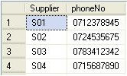

SELECT *
FROM Supplier_EmailC2207

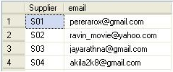

SELECT *
FROM Employee_Phone_NoC2207

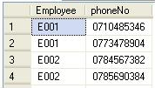

SELECT *
FROM Employee_EmailC2207

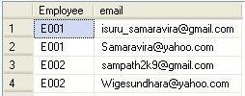

Sample Queries

--group by 1 (Number of Phone Numbers that each Custemaer has)
select Customer, COUNT(phoneNo) Phone_Numbers
from Customer_Phone_NoC2207
group by Customer;

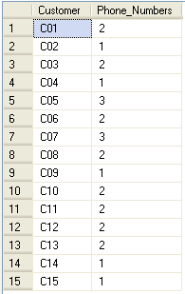

--group by 2 (Number of Employees in each Division)
select Division, COUNT(eid) Employees
from EmployeeC2207
group by Division;

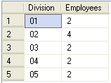

--group by 3 (Total payments for each Supplier)
select supplier, SUM(sup_payment) Total_Payment
from Movie_CopyC2207
group by supplier;

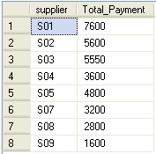

--group by 4 (Total number of Movies supplied by each day)
SELECT Sup_date,COUNT(*)AS NumOfMovies
FROM Movie_CopyC2207
GROUP BY Sup_date;

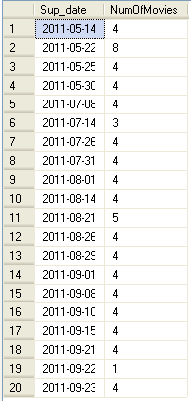

--group by 5 (Number Of Movies from Each itemSELECT itemNo,COUNT(*)As NumOfMovies
FROM Movie_CopyC2207
GROUP BY itemNo;

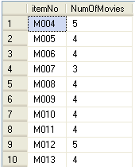

--group by 6 (number Of Movies Borrowed by each day)
SELECT borrowedDate,COUNT(*)AS numOfBorrowedMovies
from C_Borrow_and_ReturnC2207
GROUP BY borrowedDate;

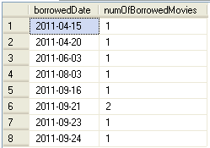

--Nested 1 (Find Registered customers who have not returned Videos on time)
select cid, NICNo, fname, lname
from CustomerC2207
where cid in ( select customer
from C_Borrow_and_ReturnC2207
where DATEDIFF(DAY, borrowedDate,
CONVERT(date,GETDATE())) > 7 and
returnDate is null);

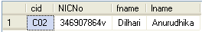

--Nested 2 (Find Employees who have borrowed videos)
select eid, NICNo, fname, lname, Division
from EmployeeC2207
where eid in ( select Employee
from E_Borrow_and_ReturnC2207)

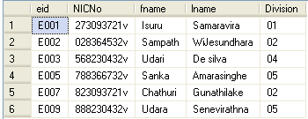

--Nested 3 (Find registerd Suppliers who have supplied more than 10 Videos)
select sid, name, address
from SupplierC2207
where sid in (select supplier
from Movie_CopyC2207
group by supplier
having COUNT(supplier) > 9);

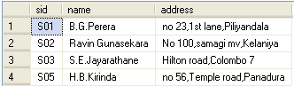

--Nested 4 (Find Registered customers who have burrowed more than 1 Videos)
select cid, NICNo, fname, lname
from CustomerC2207
where cid in ( select customer
from C_Borrow_and_ReturnC2207
group by customer
having COUNT(customer) > 1);

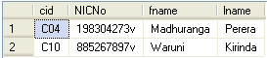

--Joint 1 (Customer Details with Phone Numbers)
SELECT c.fname,c.lname,c.address,cp.phoneNo
FROM CustomerC2207 c,Customer_Phone_NoC2207 cp
WHERE c.cid=cp.customer;

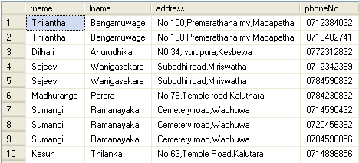

--Joint 2 (Suppliers' Phone numbers)
SELECT sid, name, phoneNo
FROM SupplierC2207 s,Supplier_Phone_NoC2207 sp
WHERE s.sid=sp.Supplier;

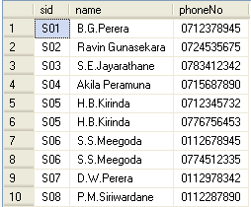

--Joint 3 (Employees with their Division Details) SELECT e.eid,e.fname,e.lname,d.name,d.location,d.phoneNo
FROM EmployeeC2207 e,DivisionC2207 d
WHERE e.Division =d.did;

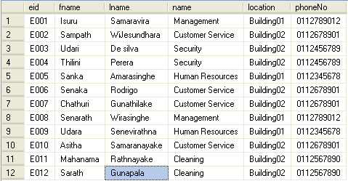

Interfaces

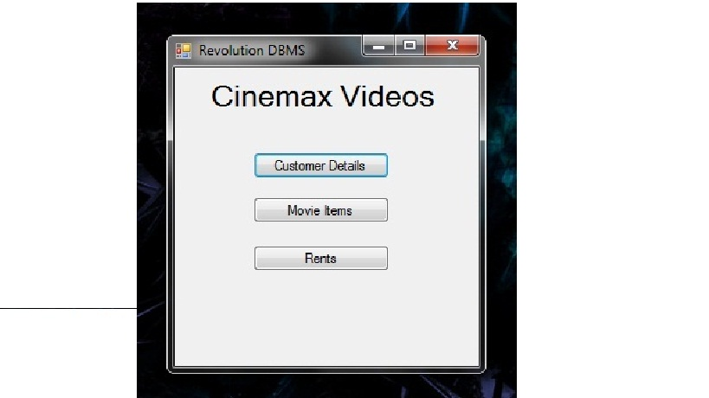

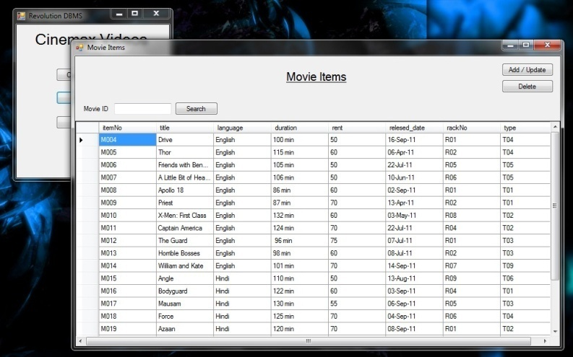

Main Window Movie Items

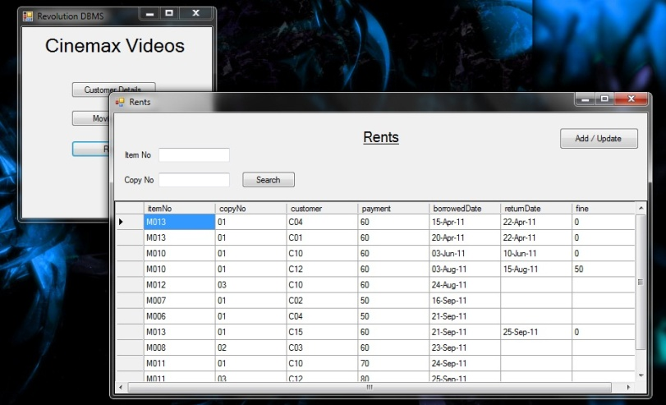
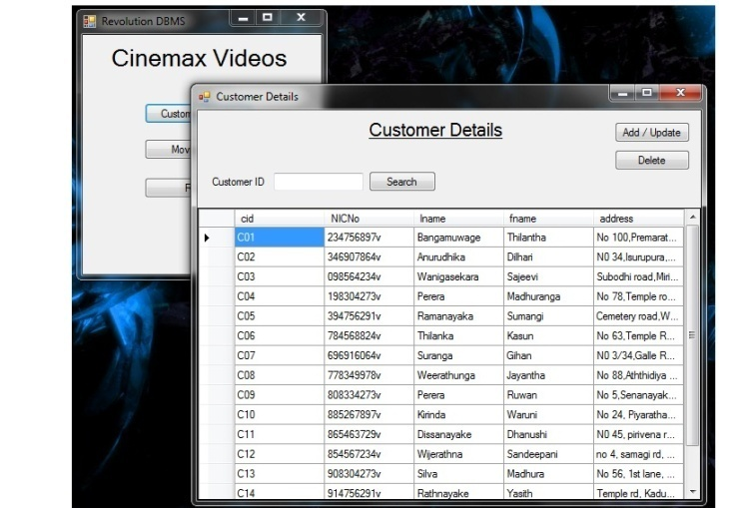

Customer Details Rent Details

